Week 6
1. Write a Python program that inputs two tuples and creates a third that contains all elements of the first followed by all elements of the second.

def concatenate_tuples(tup1, tup2):
return tup1 + tup2

tup1 = tuple(input("Enter Elements of first tuple: ").split())
tup2 = tuple(input("Enter Elements of first tuple: ").split())
tup3 = concatenate_tuples(tup1, tup2)
print(tup3)

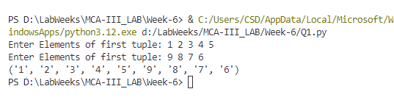

2. Write a Python program to create a dictionary with names and phone numbers. Then ask the user for a name and print the corresponding phone number.

def create_phonebook():
phonebook = {}
phonebook["Alice"] = "123-456-7890"
phonebook["Bob"] = "234-567-8901"
phonebook["Charlie"] = "345-678-9012"
return phonebook

def get_phone_number(phonebook, name):
return phonebook.get(name, "Name not found")

phonebook = create_phonebook()
name = input("Enter a name: ")
print("Phone number:", get_phone_number(phonebook, name))

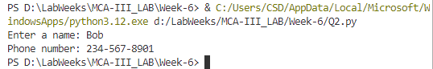

3. Write a Python program to calculate the sum of squares of the first two digits and the last two digits of a 4-digit number, e.g., for 1233, calculate 12^2 + 33^2.

def sum_of_squares(num):
if num<=9999 and num >= 1000:
first_two = int(str(num)[:2])
last_two = int(str(num)[-2:])
return first_two**2 + last_two**2
else:
print("Enter 4 digit number")
return
number = int(input("Enter Number: "))
print("Sum of squares:", sum_of_squares(number))

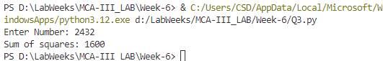
4. Write a program that inputs a main string and creates an encrypted string by embedding a short symbol-based string after each character. The program should also decrypt the string.

def encrypt_string(main_str, symbol_str):
encrypted = ''.join([char + symbol_str for char in main_str])
return encrypted

def decrypt_string(encrypted_str, symbol_str):
return encrypted_str.replace(symbol_str, '')

main_str = input("Enter a String: ")
symbol_str = input("Enter symbol: ")
encrypted = encrypt_string(main_str, symbol_str)
print("Encrypted string:", encrypted)
decrypted = decrypt_string(encrypted, symbol_str)
print("Decrypted string:", decrypted)

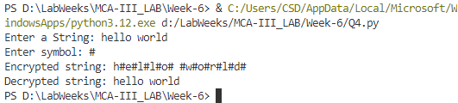

5. Write a program to get roll numbers, names, and marks of students and store these details in a file called "Marks. data".
def store_student_details(filename):
with open(filename, 'a') as file:
while True:
roll_number = input("Enter roll number: ")
name = input("Enter name: ")
marks = input("Enter marks: ")
file.write(f"{roll_number},{name},{marks}\n")
cont = input("Enter y if you want to add another student: ")
if cont.lower() != 'y':
break

store_student_details("Marks.data")
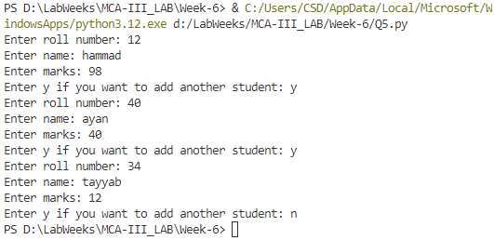

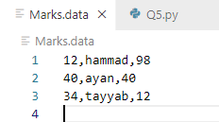

6. Write a program to accept a string and display:
a. Number of uppercase characters
b. Number of lowercase characters
c. Total number of alphabets
d. Number of digits

def char_counts(s):
uppercase = sum(1 for c in s if c.isupper())
lowercase = sum(1 for c in s if c.islower())
alphabets = sum(1 for c in s if c.isalpha())
digits = sum(1 for c in s if c.isdigit())
return uppercase, lowercase, alphabets, digits

s = input("Enter a string: ")
uppercase, lowercase, alphabets, digits = char_counts(s)
print("Uppercase characters:", uppercase)
print("Lowercase characters:", lowercase)
print("Total alphabets:", alphabets)
print("Digits:", digits)

